Batch: B2 Roll No.: 16010122158

Experiment 03

Title: Tableau- Importing Data

Objective:

1. To learn how to import dataset from various file format

Text, csv, pdf, excel, word

2. To learn how to import dataset from various server

Course Outcome:

CO1: Learn how to locate and download datasets, extract insights from that data and present their findings in a variety of different formats.

Books/ Journals/ Websites referred:
https://www.stats.govt.nz/large-datasets/csv-files-for-download/
https://www.kaggle.com/datasets/shekpaul/global-superstore
http://courses.washington.edu/b517/Datasets/datasets.html
https://dataverse.harvard.edu/dataset.xhtml?persistentId=doi:10.7910/DVN/DJHVHB
https://www.kaggle.com/datasets/danushkumarv/glass-identification-data-set

Resources used:
Tableau, Excel, Notepad, Online Datasets
https://www.stats.govt.nz/large-datasets/csv-files-for-download/
https://www.kaggle.com/datasets/shekpaul/global-superstore
http://courses.washington.edu/b517/Datasets/datasets.html
https://dataverse.harvard.edu/dataset.xhtml?persistentId=doi:10.7910/DVN/DJHVHB
https://www.kaggle.com/datasets/danushkumarv/glass-identification-data-set

Theory (About Data Preprocessing):
Data preprocessing is the process of transforming raw data into a useful, understandable format. Real-world or raw data usually has inconsistent formatting, human errors, and can also be incomplete. Data preprocessing resolves such issues and makes datasets more complete and efficient to perform data analysis.

Following points should be written by students

Different approaches of importing dataset:

Import from various file format (pdf, excel, csv, text etc)

Import from server (min one server of choice)

Platform used by the student: Tableau, Google Drive, MS Excel

Working: (Screenshots of various file format imported in tableau software)
Import from File formats:
Importing Text file:

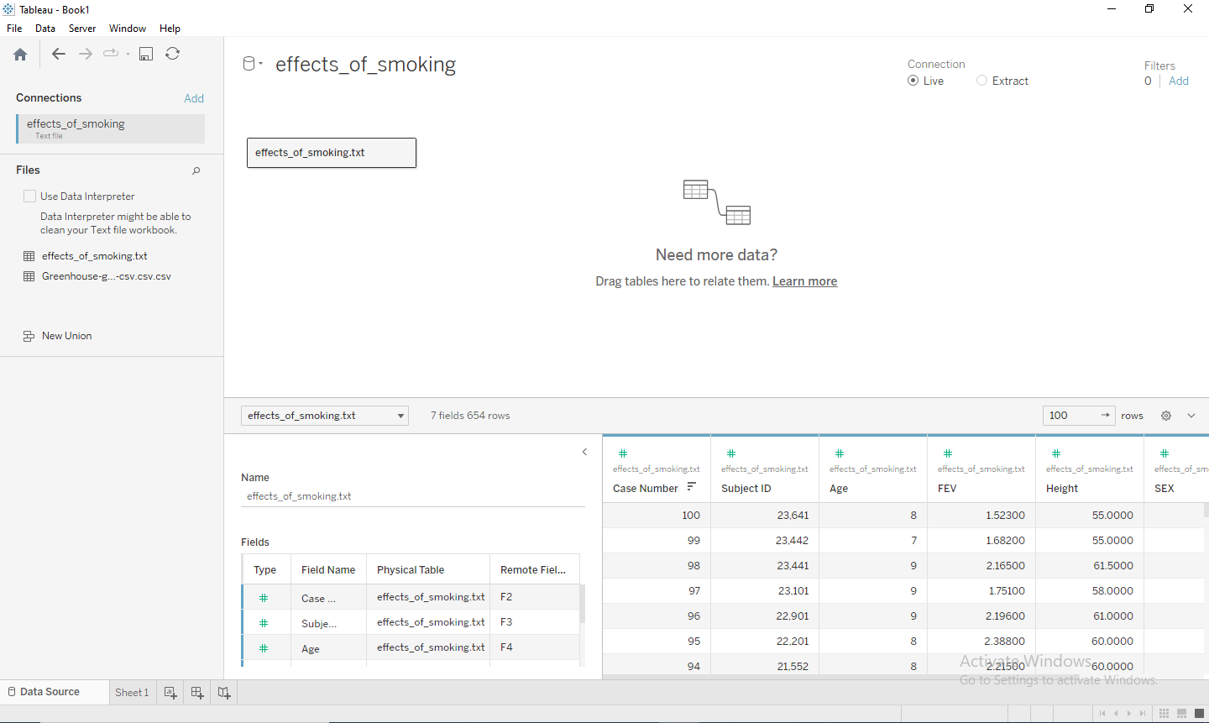

Importing CSV file:
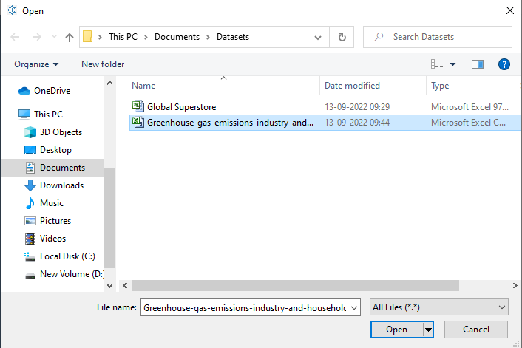
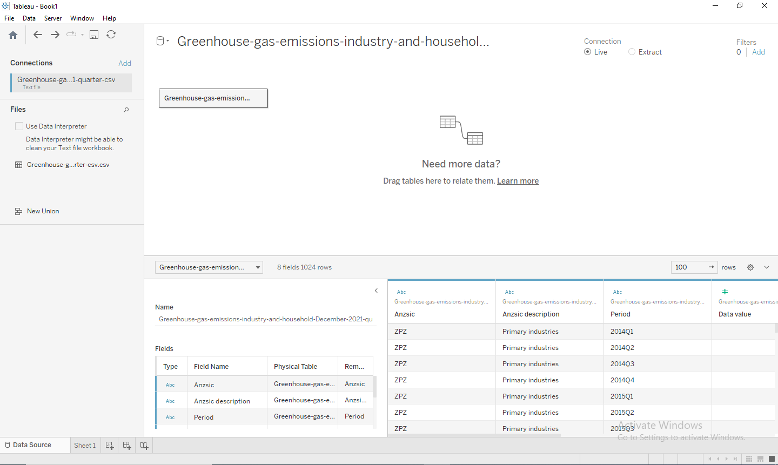

Importing pdf file:
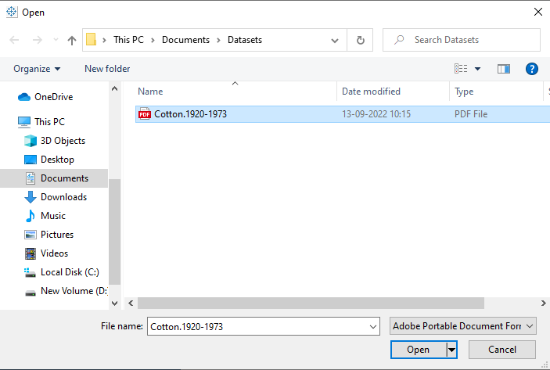
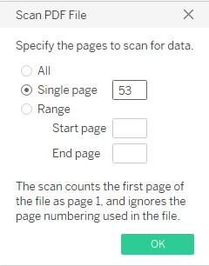
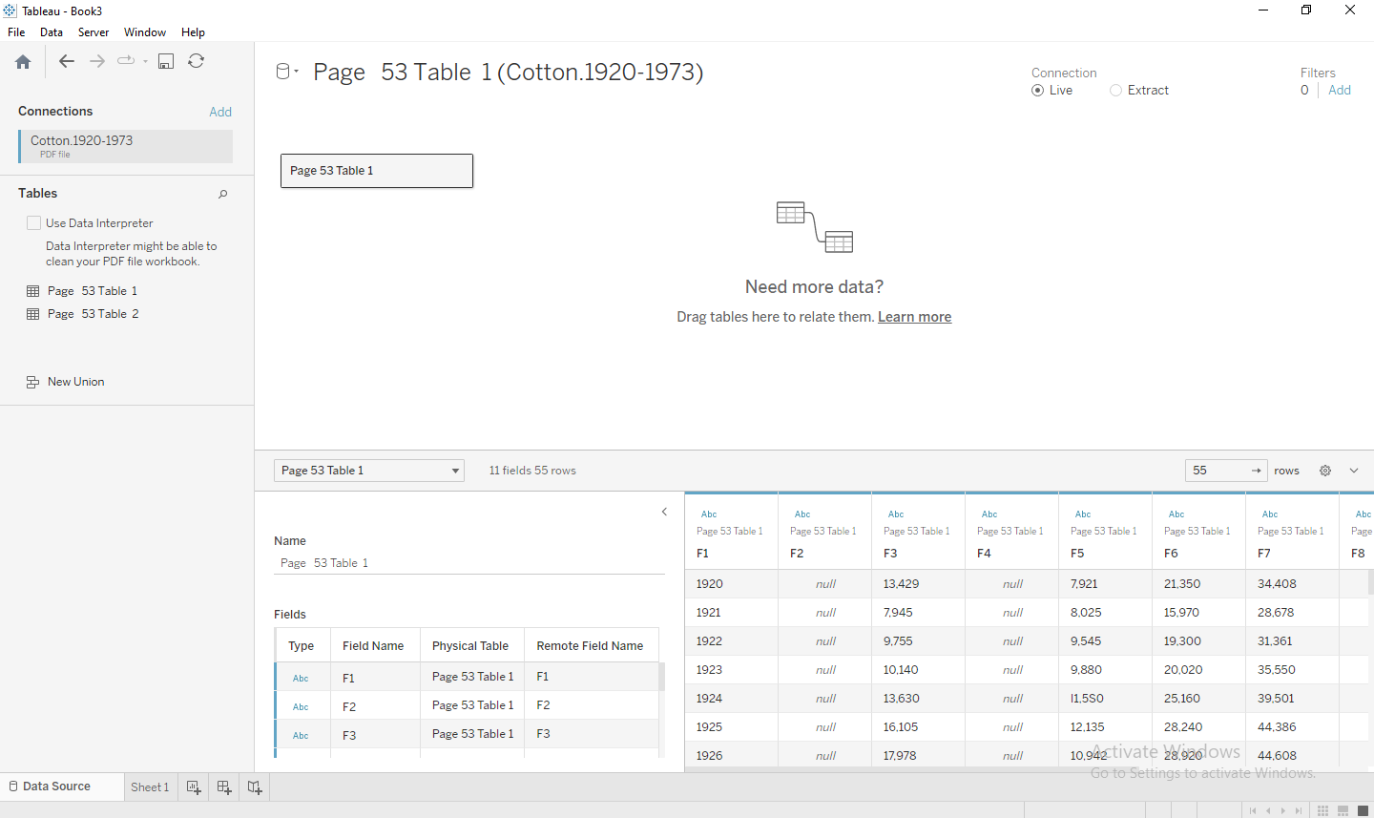

Importing Excel file:

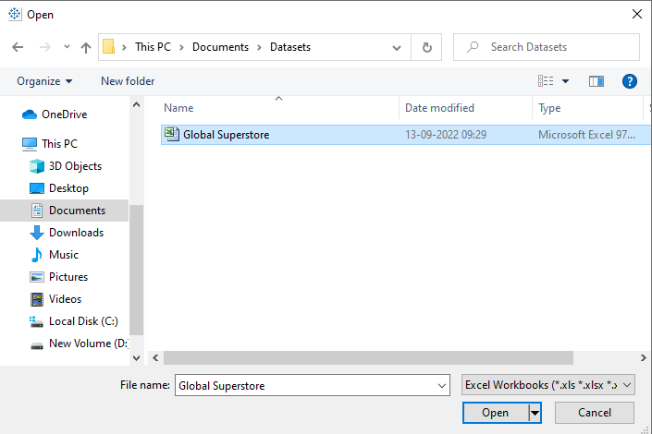
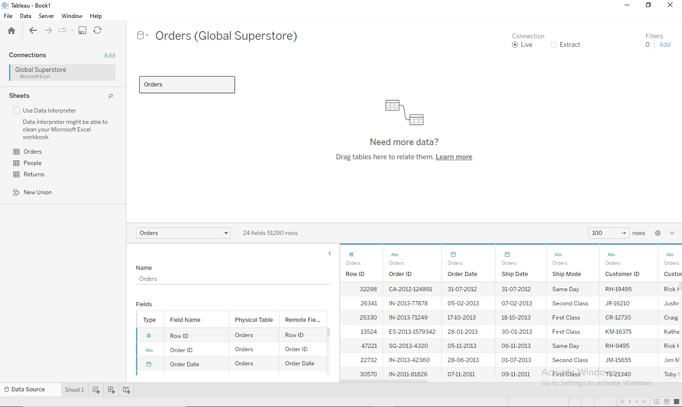
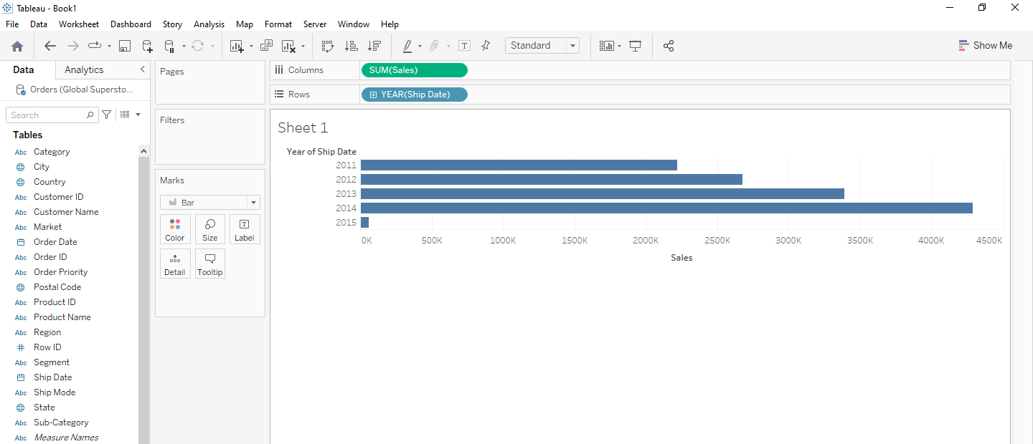
Import from Servers:
Importing from Google Drive:


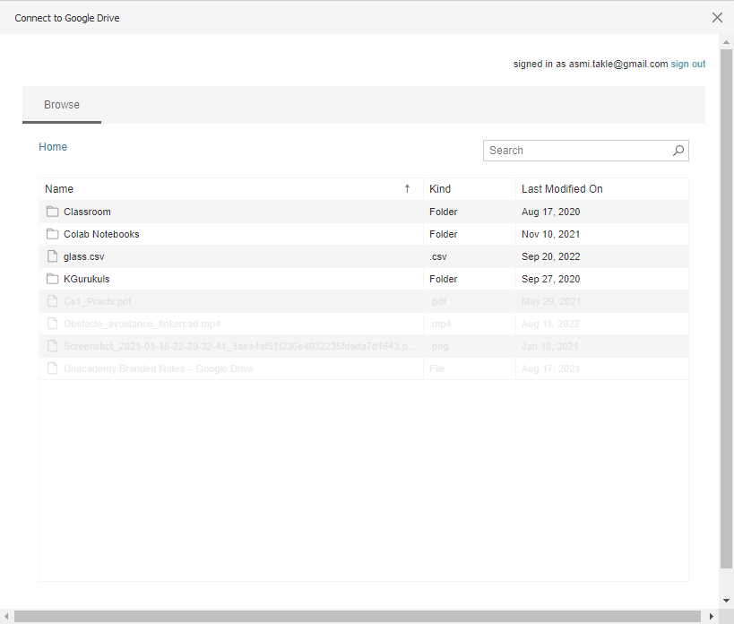
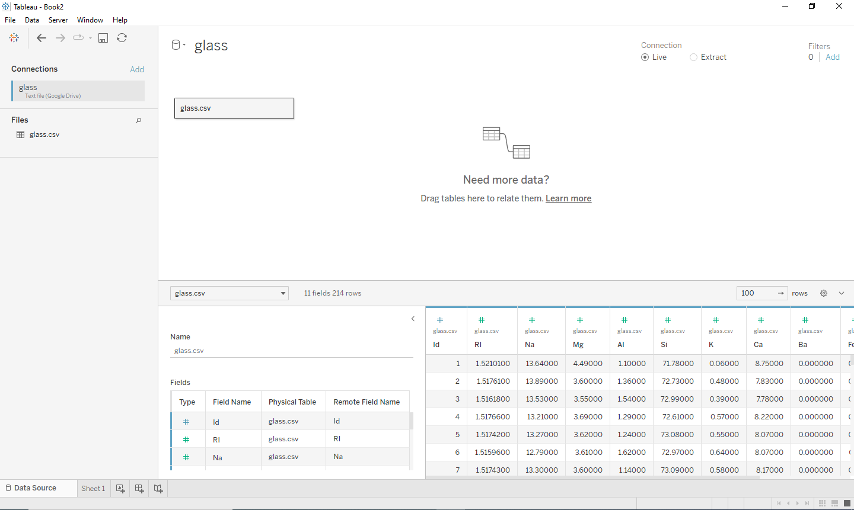

Conclusion (Students should write in their own words):
Tableau supports importing data from various file formats like text, csv, pdf, excel and also from various servers like Google Drive, MySQL.

Post Lab Question:

List down types of data Tableau can import?
Types of data Tableau can import from are:
- Microsoft Excel
- Text file
- JSON file
- Microsoft Access
- PDF file
- Spatial file
- Statistical file

What is the significance of Measures and Dimensions in the dataset stored in Tableau?
Measures contain numeric, quantitative values that you can measure. Measures can be aggregated. When you drag a measure into the view, Tableau applies an aggregation to that measure (by default).
Dimensions contain qualitative values (such as names, dates, or geographical data). You can use dimensions to categorize, segment, and reveal the details in your data. Dimensions affect the level of detail in the view.

Date: 17/10/2023 Signature of faculty in-charge

